Assignment 2 Report – Introduction to Linux Basic Commands
Student Name: Ufiteyezu Mpore Kevin
Student ID: 21831
Course: COSC 8312
Institution: Adventist University of Central Africa
Assignment: simulate forensic investigation and system admin tasks
Due Date: 04.12. 2025

Investigating Compromised System Directories (2 pts)
Task: Identify which directories may contain system configs, essential binaries, and logs that attackers could target.
Answer:
- /bin → essential binaries

- /etc → system configs

- /var → logs (evidence of intrusion)

- /usr → installed applications/libraries

- /tmp → temporary attacker payloads

- /opt → third-party apps (hidden malware possible)

- /boot → bootloader/kernel (persistence risk)

- /home → user files/dotfiles (backdoors in .bashrc, authorized_keys)

Commands Run:
ls -ld /bin /etc /var /usr /tmp /opt /boot /home
ls -l /var/log | head
find /bin /usr/bin -perm /6000 -type f -ls | head

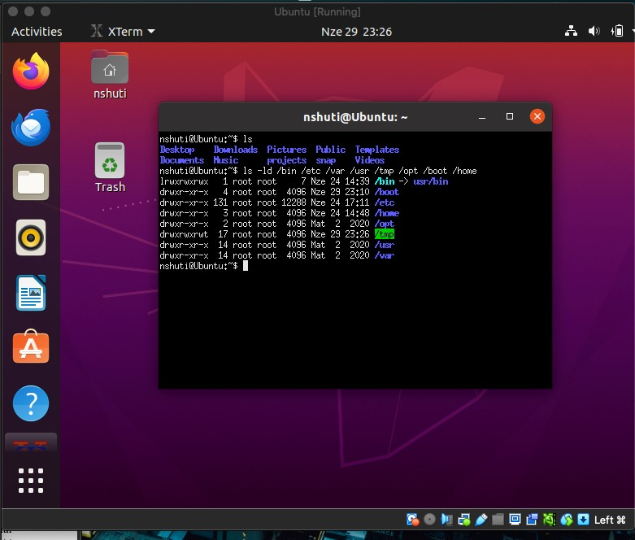
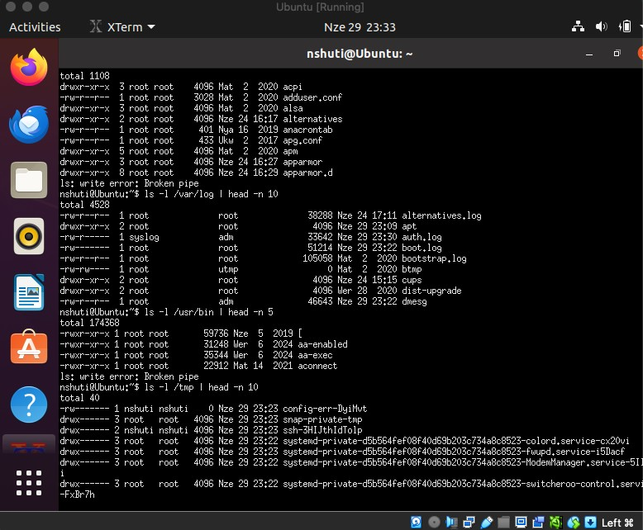

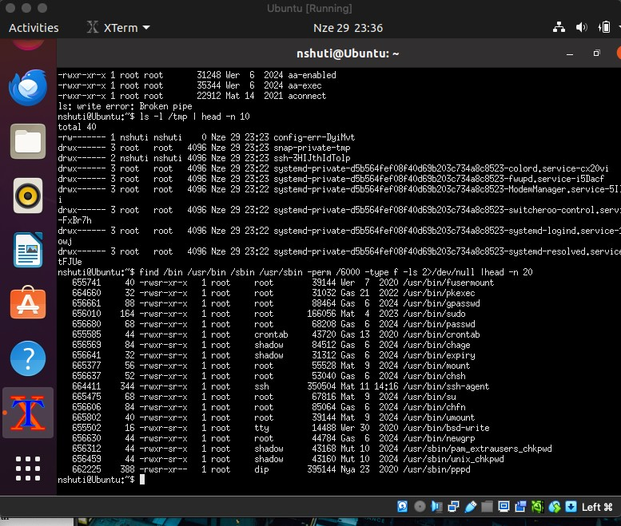

Q2. Directory Structure Creation (2 pts)
Task: Create a project structure with minimal commands.
Commands:
mkdir -p
~/ia2_work/projects/{client1/{src,tests,docs},client2/{src,tests,docs}
,personal/{notes,experiments}} tree -L 3 ~/ia2_work/projects

Q3. Relative Path Navigation (1 pt)
Task: Navigate using ≤3 cd commands.
Commands:
pwd # starting location cd ../../../../personal/experiments pwd
cd ../../shared/templates pwd
cd ../../client_work/web/frontend pwd

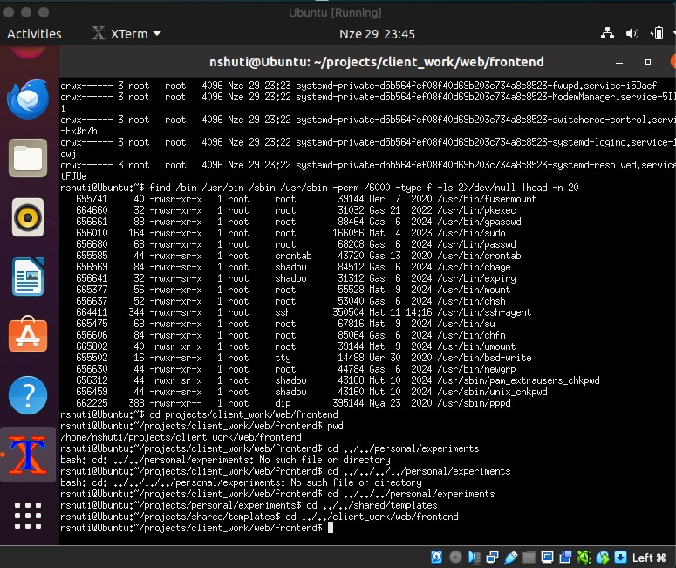

Q4. Web Project Structure (2 pts)
Task: Create HTML, CSS, JS, and backup files.
Commands:
mkdir -p web_project/{html,css,js,backups} touch web_project/html/{index,about,contact}.html
for i in $(seq -w 1 12); do touch web_project/html/page_${i}.html; done touch
web_project/css/{main,reset,theme_light,theme_dark,mobile,tablet,deskt op,print}.css touch
web_project/js/{app_script,init_script,helpers_util,dom_util,app_confi g,env_config}.js
for l in a b c d; do for n in {1..5}; do touch web_project/backups/${l}${n}.{bak,tmp,old}; done; done

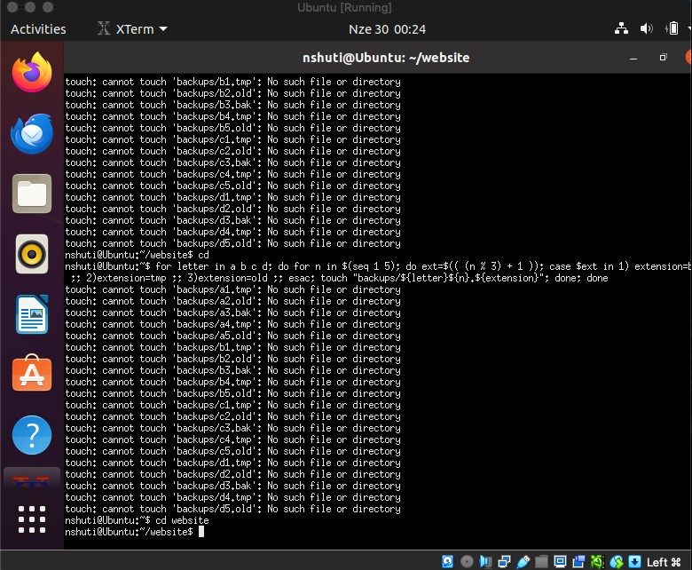

Q5. Wildcard Operations (2 pts)
Examples of patterns used:
- Move numeric: mv html/page_*.html archive/
- Copy excluding: cp css/!(mobile.css|tablet.css) css_desktop/
- Exactly 3 chars before dot: find . -regex '.*/[^/]\{3\}\.[^/]\+$'
- Consonant start: find . -regex './[b-df-hj-np-tv-z].*' ● 2-char extension: find . -regex '.*\.[[:alnum:]]{2}$'
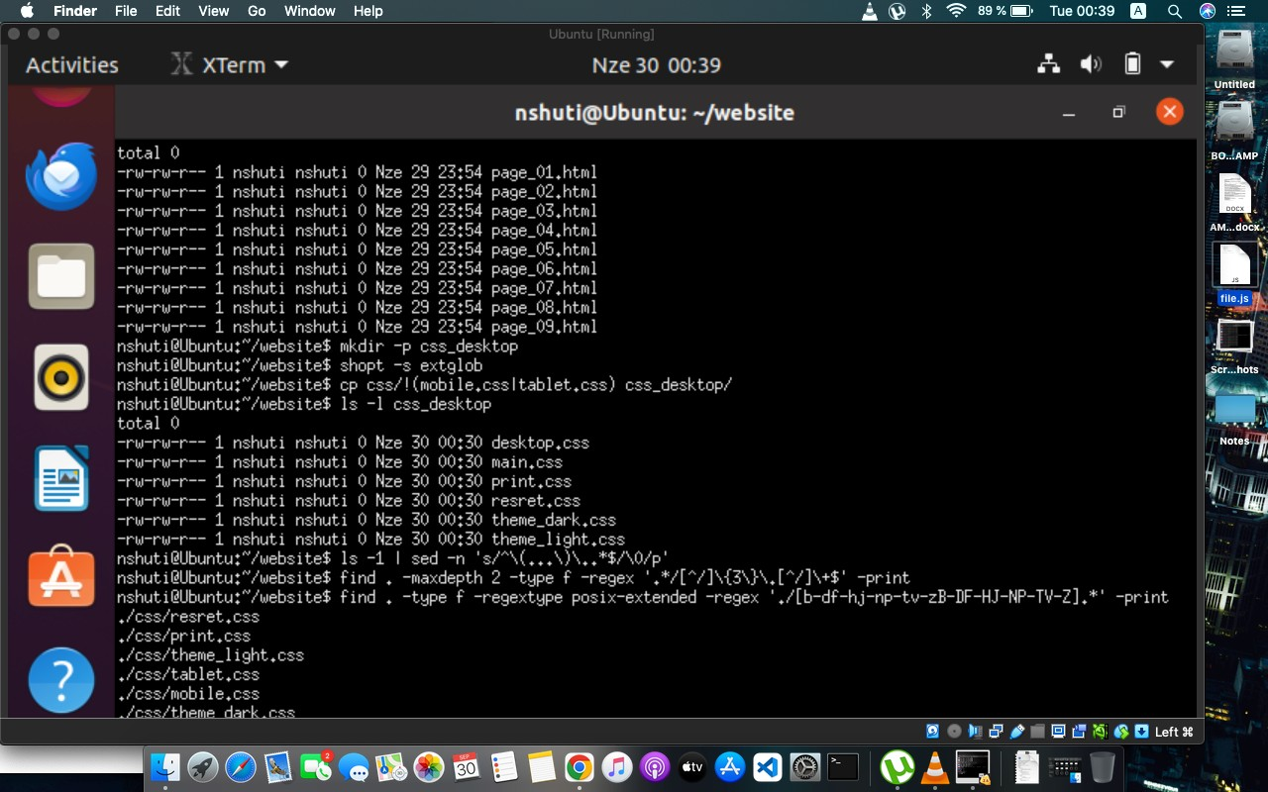

Q6. Brace Expansion (1 pt)
Commands:
for m in 01 02 03; do d=$(cal $m 2024 | awk 'NF {DAYS=$NF} END {print DAYS}'); for i in $(seq -w 1 $d); do touch logs/log_2024-$m-$i.txt; done; done
touch configs/{web,api,db}.{dev,staging,prod}.conf touch tests/{A,B,C}.{10..12}.{input,output}

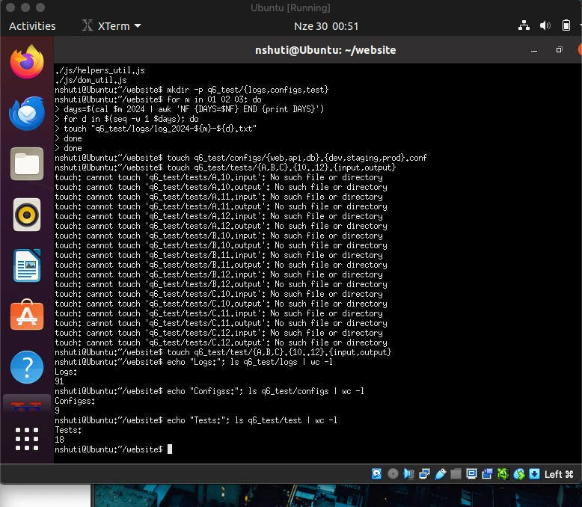

Q7. Linux vs Windows Line Endings (1 pt)
Commands:
cat > linux.txt <<EOF line one line two line three EOF
awk '{print $0"\r"}' linux.txt > windows.txt
diff linux.txt windows.txt cmp -l linux.txt windows.txt Explanation:
- diff → shows differences in lines.

- cmp → shows CR (0x0d) mismatch.

- comm → compares sorted content, ignoring line endings.

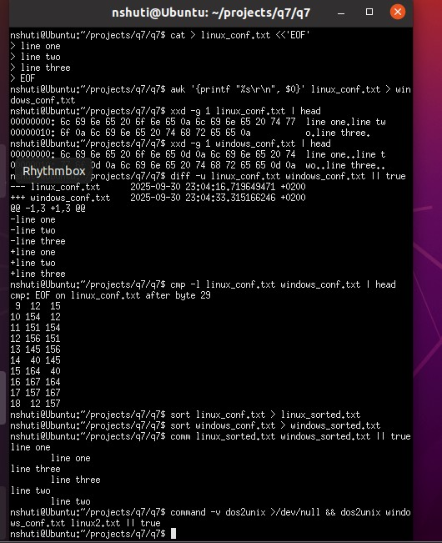

Q8. File Search with find (3 pts)
Examples:
- Larger than average: find . -size +${avg}c ● Modified last 72 but not 24h: find . -mtime -3 -mtime +1

- Empty or hidden-only dirs: find . -empty

- World writable: find . -perm -o=w

- Other owners: find . ! -user $(whoami) ! -user root
- Backup/temp names: find . -regex '.*\.\(bak\|tmp\|old\)$'
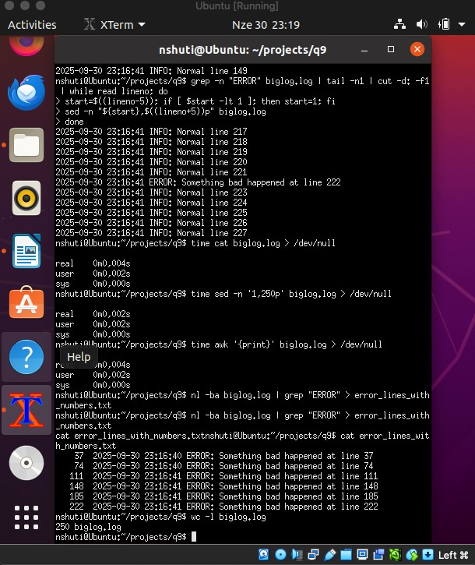

Q9.

Log

File

Analysis

(2

pts)

Commands:
for i in {1..250}; do echo "INFO line $i"; done > big.log
sed -n '101,150p' big.log grep -n "ERROR" big.log | tail -1 nl big.log | grep ERROR



Q10. File Maintenance Automation (1 pt)
Examples: ● Change perms except executables:
find . -type f ! -executable -exec chmod 644 {} \;
● Disk space older 30d:
find . -mtime +30 -print0 | du --files0-from=- -ch ● Backup configs:
find . -name '*.conf' -exec cp {} {}.backup \;
● Remove stale tmp:
find . -name '*.tmp' -atime +30 -delete
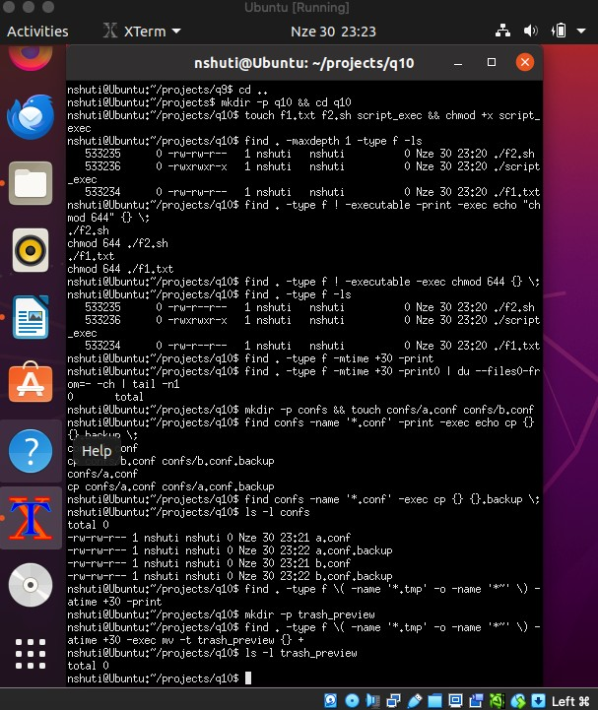

Q11. Compression Analysis (2 pts)
- Text compresses best with xz/bzip2.

- Already compressed (jpg/mp4) → no gain.

- Recommendation: tar+gzip for balance.

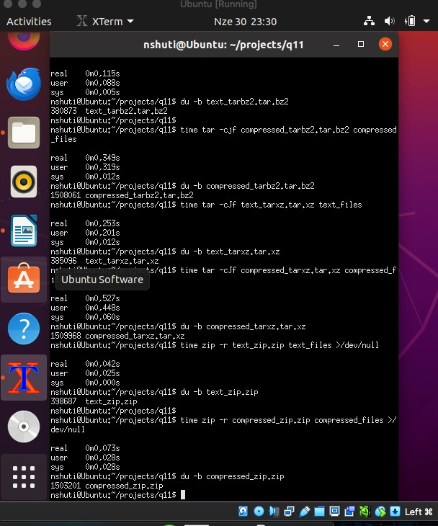

Q12. Archive Handling (1 pt)
- List contents: tar -tzf archive.tar.gz

- Selective extract: tar -xzf archive.tar.gz --wildcards '*keep*'
- Update: tar -rf archive.tar newfile

- Corrupt handling: tar -tzf archive.tar.gz || echo "bad archive"
- Merge: extract all → tar -czf new.tar.gz combined_dir/
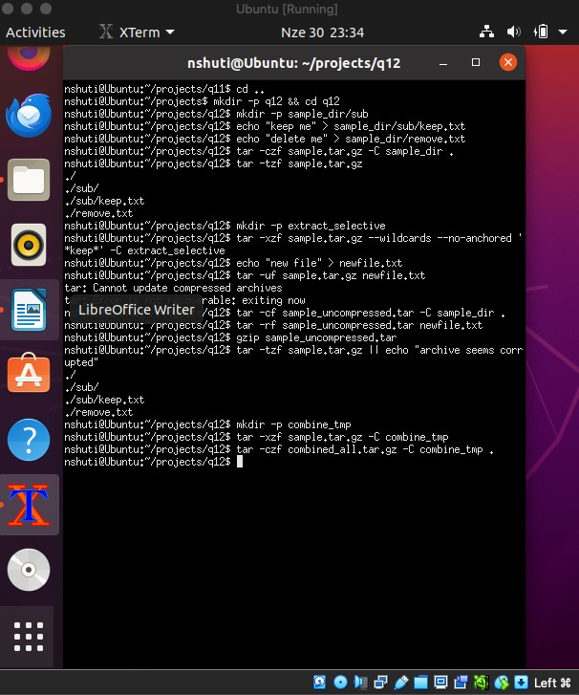

Q13. Backup Rotation (1 pt)
- Daily incremental → rsync --link-dest

- Weekly full → tar -czf backup-full-YYYYMMDD.tar.gz
- Monthly archive → move weekly → monthly/

- Cleanup → find backups/daily -mtime +14 -exec rm -rf {} \;
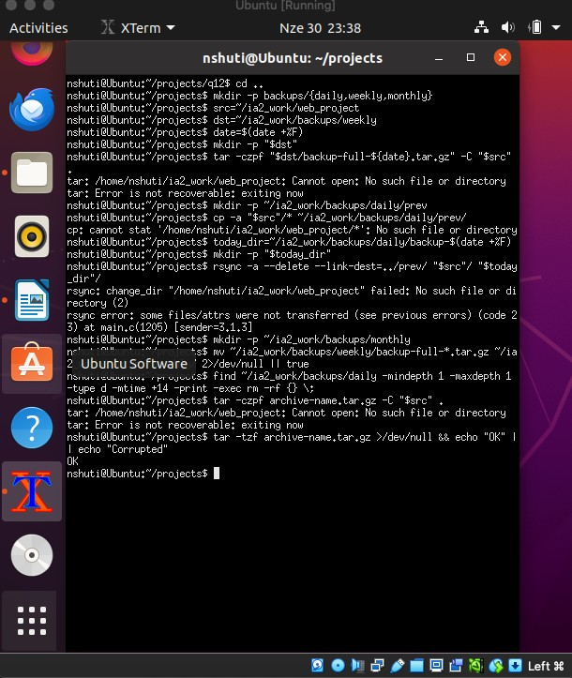

Q14. User & Groups Analysis (2 pts) Commands:
id groups
awk -F: '{print $1,$3,$6}' /etc/passwd | head

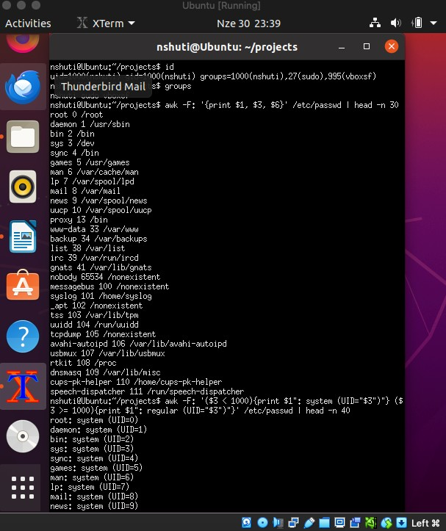

Q15. Group Membership Propagation (1 pt)
- Add user to group: sudo usermod -aG demo_group $USER
- Effective only after re-login → or use newgrp.

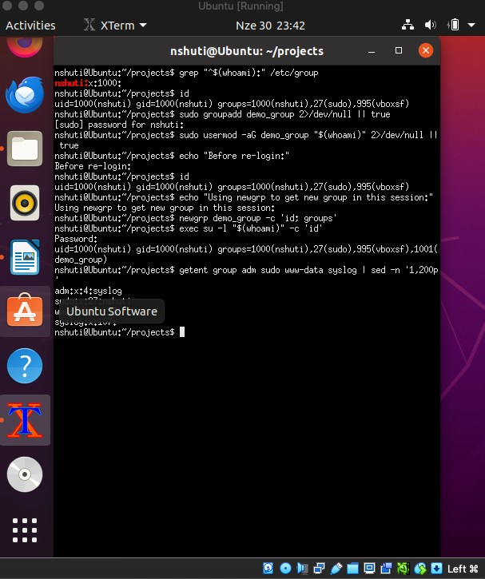

Q16. Sudo Audit (1 pt)
- List privileges: sudo -l

Compare: sudo -i, sudo su, su -

- Run as another user: sudo -u nobody id

- Audit logs: grep sudo /var/log/auth.log
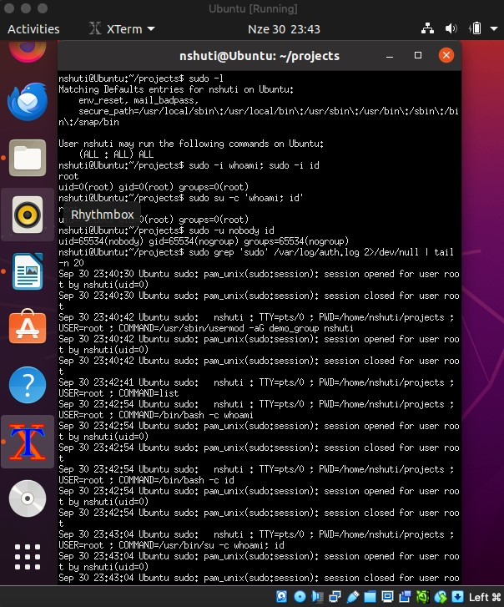

Bonus Q17. Forensic Environment (2 pts)
Create files: touch regular.txt

- Symlinks: ln -s regular.txt sym.txt

- Hard links: ln regular.txt hard.txt

- SUID/SGID: chmod 4755 suid_file
- Sticky dir: chmod 1777 sticky_dir

- Archives: tar -czf file.tar.gz regular.txt
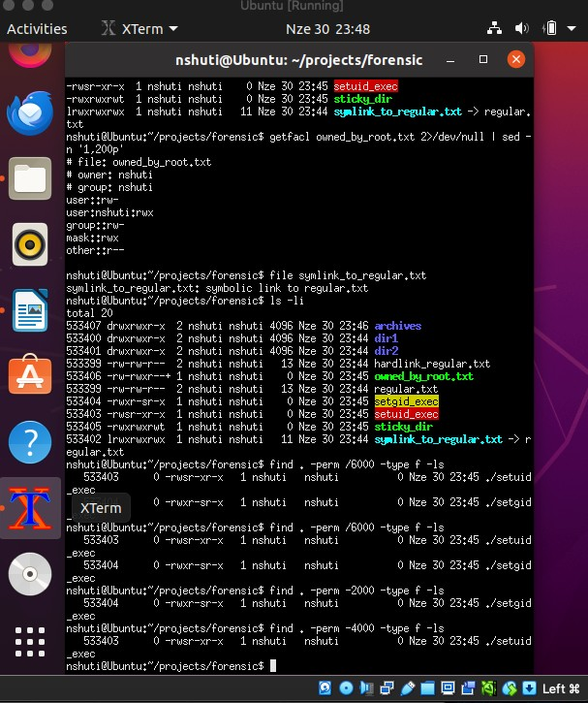

📝 Reflection
What I Did: Summarized Linux filesystem investigation, permissions, backups, and archives.

- Why I Did It: To simulate forensic investigation and system admin tasks.

- What I Learned: File manipulation, wildcard power, backup strategies, security audit basics.

- Challenges: VirtualBox Guest Additions setup, permissions issues.

- Recommendations: Automate repetitive tasks with scripts, always test dangerous commands with -print before executing.

